**MM804 GRAPHICS AND ANIMATION Assignment 2 Solution**

**Question 1:**

The file used to Clip the polygonal data is **Hulk.STL** is a 3d model of a Hulk.

The size of the model is 44MB and the model can be found here.

[**https://www.thingiverse.com/thing:993933/files**](https://www.thingiverse.com/thing:993933/files)**.**

**Question 2:**

Vertices of the original Model: 1350510

Vertices of the Clipped-out part of the Model:

Vertices of the Remaining part of the Model:

Vertices to the Intersection part of the Model:

**Question 3:**

Sample Screenshots of some of the output images

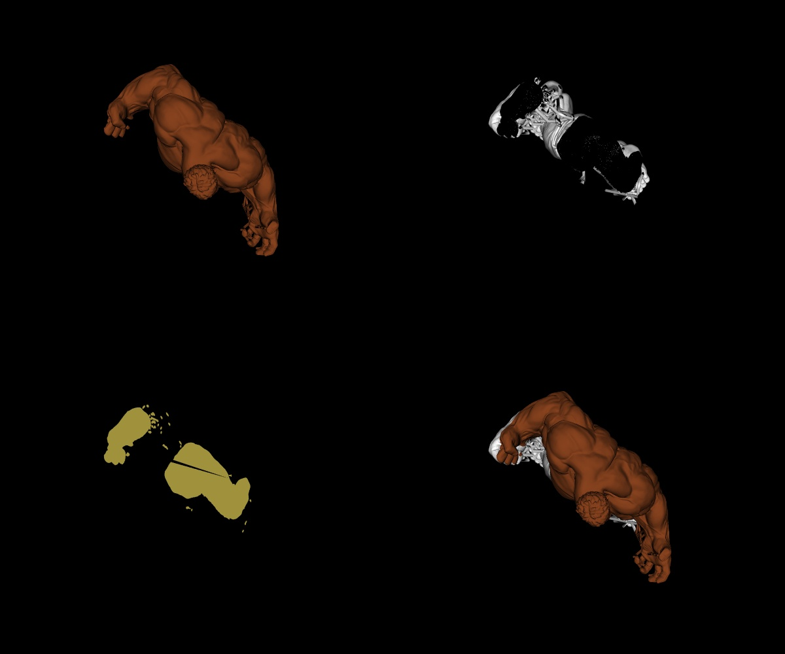

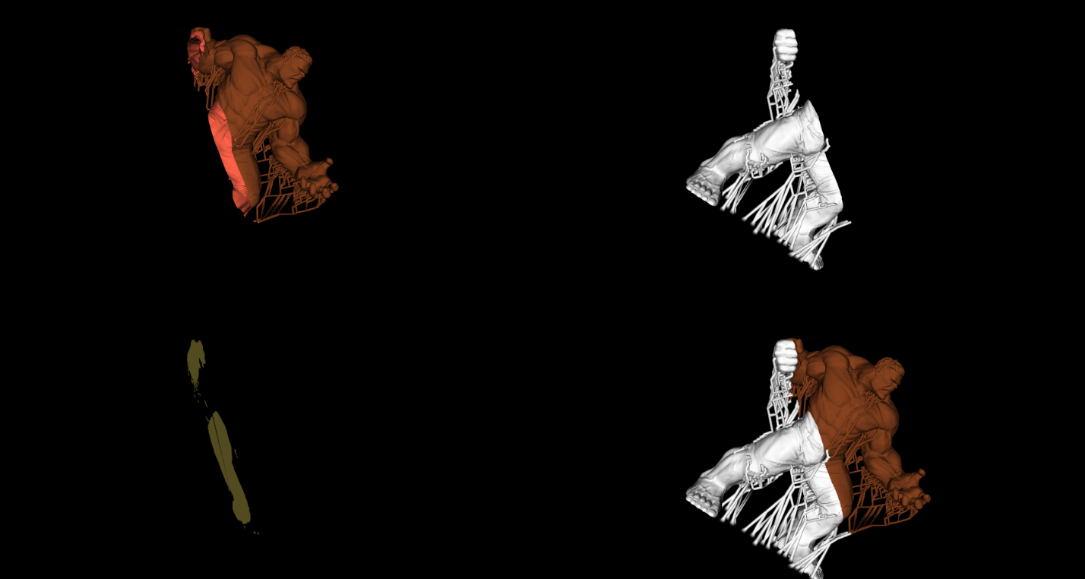

**Question 4:**

Source Code with comments in Human Readable Format

import vtk

from vtk.util.colors import brown_ochre, tomato, banana

# Initial model vertices using pyvista

import pyvista as pv

import numpy as np

mesh = pv.read('Hulk.stl')

print(mesh.points.size)

# https://www.thingiverse.com/thing:993933/files

# Question 1. Read the 3d  model input stl  file using vtkSTLReader

inputFile = vtk.vtkSTLReader()

inputFile.SetFileName("Hulk.stl")

# Create Mapper for the input file using vtkPolyDataMapper

fileMapper = vtk.vtkPolyDataMapper()

fileMapper.SetInputConnection(inputFile.GetOutputPort())

# Get and store center and normals of the 3d- model using GetCenter()

getCenter = fileMapper.GetCenter()

inputNormals = vtk.vtkPolyDataNormals()

inputNormals.SetInputConnection(inputFile.GetOutputPort())

# Question 2. Create plane for the model with origin as center of 3d object data and set normal using vtkPlane()

objectPlane = vtk.vtkPlane()

objectPlane.SetOrigin(getCenter)

objectPlane.SetNormal(1,0,1) # Assigning the normal vector to [1,0,1] as mentioned

# Question 3. Create a clipper to clip the object/data using vtkClipPolyData

objectClipper = vtk.vtkClipPolyData()

objectClipper.SetInputConnection(inputNormals.GetOutputPort())

objectClipper.SetClipFunction(objectPlane) #setup the plane to clip the data.

objectClipper.GenerateClipScalarsOn() #represent output scalar values

objectClipper.GenerateClippedOutputOn() #Generate clipped out data

objectClipper.SetValue(0) #Clipping values to 0.

# clip the data mapper using vtkPolyDataMapper

objectClipMapper = vtk.vtkPolyDataMapper()

objectClipMapper.SetInputConnection(objectClipper.GetOutputPort())

objectClipMapper.ScalarVisibilityOff()

backProp = vtk.vtkProperty()

backProp.SetDiffuseColor(tomato)

# Create clip actor and gettin the meta data of the clipped model

objectClipActor = vtk.vtkActor()

objectClipActor.SetMapper(objectClipMapper)

objectClipActor.GetProperty().SetColor(brown_ochre) # adding color to the clipped data

objectClipActor.SetBackfaceProperty(backProp)

print(objectClipActor.GetProperty())

# Question 4. Show the intersection area between the plane and polygonal data.

# creating a VTK Cutter to display intersection area

objectCutEdges = vtk.vtkCutter()

objectCutEdges.SetInputConnection(inputNormals.GetOutputPort())

objectCutEdges.SetCutFunction(objectPlane)

objectCutEdges.GenerateCutScalarsOn()

objectCutEdges.SetValue(0, 0)

# creating a vtkStripper

objectCutStrips = vtk.vtkStripper()

objectCutStrips.SetInputConnection(objectCutEdges.GetOutputPort())

objectCutStrips.Update()

objectCutPoly = vtk.vtkPolyData()

objectCutPoly.SetPoints(objectCutStrips.GetOutput().GetPoints()) # Get points from strips

objectCutPoly.SetPolys(objectCutStrips.GetOutput().GetLines()) # Create polygonal data to be displayed

# Create Triangle Filter

objectCutTriangles = vtk.vtkTriangleFilter()

objectCutTriangles.SetInputData(objectCutPoly)

objectCutMapper = vtk.vtkPolyDataMapper()

objectCutMapper.SetInputData(objectCutPoly)

objectCutMapper.SetInputConnection(objectCutTriangles.GetOutputPort())

objectCutActor = vtk.vtkActor()

objectCutActor.SetMapper(objectCutMapper)

objectCutActor.GetProperty().SetColor(banana)

# Create mapper and actor for remaining un-clipped data

objectRestMapper = vtk.vtkPolyDataMapper()

objectRestMapper.SetInputData(objectClipper.GetClippedOutput())

objectRestMapper.ScalarVisibilityOff()

objectRestActor = vtk.vtkActor()

objectRestActor.SetMapper(objectRestMapper)

objectRestActor.GetProperty().SetRepresentationToWireframe()

# Initialize output render window

renderingWindow = vtk.vtkRenderWindow()

renderingWindow.SetSize(1200, 1000) #Set render window size.

windowInteractor = vtk.vtkRenderWindowInteractor()

windowInteractor.SetRenderWindow(renderingWindow)

# Locations of the viewports

minX=[0,.5,0,.5]

maxX=[0.5,1,0.5,1]

minY=[0,0,.5,.5]

maxY=[0.5,0.5,1,1]

# Question 5: Initialize view ports and set location

# Bottom left

objectBottomLeft = vtk.vtkRenderer()

renderingWindow.AddRenderer(objectBottomLeft)

objectBottomLeft.SetViewport(minX[0],minY[0],maxX[0],maxY[0])

# Bottom right

objectBottomRight = vtk.vtkRenderer()

renderingWindow.AddRenderer(objectBottomRight)

objectBottomRight.SetViewport(minX[1],minY[1],maxX[1],maxY[1])

# Top left

objectTopLeft = vtk.vtkRenderer()

renderingWindow.AddRenderer(objectTopLeft)

objectTopLeft.SetViewport(minX[2],minY[2],maxX[2],maxY[2])

# Top right

objectTopRight = vtk.vtkRenderer()

renderingWindow.AddRenderer(objectTopRight)

objectTopRight.SetViewport(minX[3],minY[3],maxX[3],maxY[3])

# Add actors to viewports

objectTopLeft.AddActor(objectClipActor)

objectBottomLeft.AddActor(objectCutActor)

objectTopRight.AddActor(objectRestActor)

objectBottomRight.AddActor(objectClipActor)

objectBottomRight.AddActor(objectCutActor)

objectBottomRight.AddActor(objectRestActor)

# SetActiveCameras the current active camera of the rendering display

# This allows the visualization to be viewed from same angel in all four viewports

objectTopRight.SetActiveCamera(objectTopLeft.GetActiveCamera());

objectBottomRight.SetActiveCamera(objectTopLeft.GetActiveCamera());

objectBottomLeft.SetActiveCamera(objectTopLeft.GetActiveCamera());

objectTopLeft.ResetCamera()

# Display the output window with all the representations

renderingWindow.Render()

renderingWindow.SetWindowName('MM 804 Assignment2 output') # Set the windows name

# Converting the rendered scene to JPEG image format of a single view

windowImageFilter = vtk.vtkWindowToImageFilter()

windowImageFilter.SetInput(renderingWindow)

windowImageFilter.ReadFrontBufferOff()

windowImageFilter.Update()

# Writing it to a image

windowImageWriter = vtk.vtkJPEGWriter() # Create a jpeg file writer

windowImageWriter.SetFileName('finalOutput.jpg') # output jpeg filename.

windowImageWriter.SetInputConnection(windowImageFilter.GetOutputPort()) # Get render window scene

windowImageWriter.Write()

windowInteractor.Start()

**Question 5:**

Readme File

**Development Environment**

- Python - 3.10.0

- VTK - 9.1.0

- OS - Windows 11

**How to run:**

Open file Assignment2.ipynb either in Google Colab or Jupyter-Notebook and execute cell wise for the output window to render